92.09.27
From Leonard Rodway
RB MSS M17, Library, Royal Botanic Gardens Melbourne.

Hobart,
Sept. 27th /92.
Dear Baron,
Some months ago I had numerous specimens of Actinotus bellidioides sent me from Mt. Dundas. They were easily sortable into two varieties identical with the figures in Hook. Fl. Tas. as var. suffocata & var. fulva (but never with petals).
I have been submitting them lately to a careful examination & find that though the latter variety corresponds thoroughly with the type the variety suffocata, in every instance I examined differed in two remarkable features namely even in the youngest flowers there was no trace of a calyx-limb & the stamens were reduced to two & inserted into notches at the foot of the enlarged base of the style on the dorsal aspect of the carpels.
Unfortunately all the best specimens I sent away some time ago trusting to procure more, but the opportunity has passed & I may be unable to procure more for years I enclose however what I have not already destroyed together with a copy of details of the plant drawn from microscopic observation.
I trust that I am not wasting your time over a matter of little consequence.
Believe me
Yours Faithfully
L. Rodway.

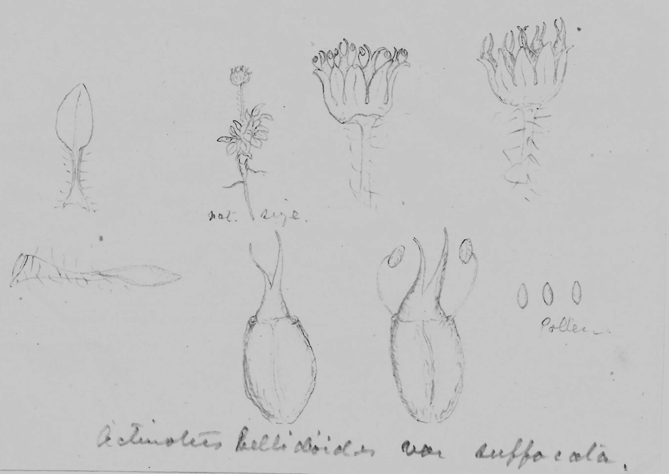

Actinotus bellidioides var fulva
Actinotus bellidioides var suffocata

MS found with a specimen of Actinotus bellidioides var. suffocata (MEL 230045). MS annotations by M: 'Seneca' and 'Answ 3/10/92'. Letter not found.
Tas.
J. Hooker (1860), part 1, p. 158, and tab. 36, as Hemiphues bellidioides.
MS is accompanied by a small square of paper with several pencil sketches, now very faint, that are reproduced here; see 92-09-27_image01.jpg (in the original, the drawing labelled 'nat size' is 26 mm high). Rodway (1894), p. 180 and plate 2, figs 1-5 discusses the issue and raises Hooker's variety suffocata to species rank. The published drawings are very similar to equivalent ones given here.

